PYTHON comments

COMMENTS IN PYTHON

* Comments can be used to explain python code
* Comments can be used to make the code readable
* Comments can be used to avoid executing a block or line of code during a test

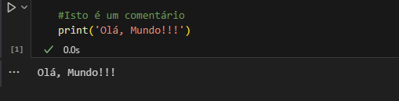Comments start with # and python will ignore them:

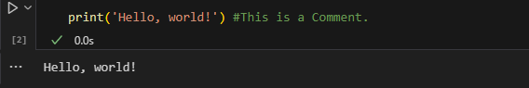Comments can be positioned at the end of a line, so python will ignore everything else:

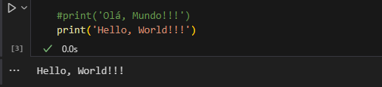They can also be used to avoid the execution of a line of code:

MULTLINE COMMENTS

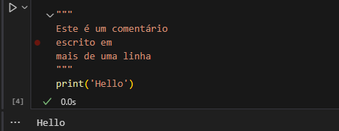To add comments on multiple lines you can add # on each line, or not as comment exactly, you can use a multiline string

As long as the string isn't assigned to a variable, python will read the code and then ignore them, so you'll have a multi-line comment.